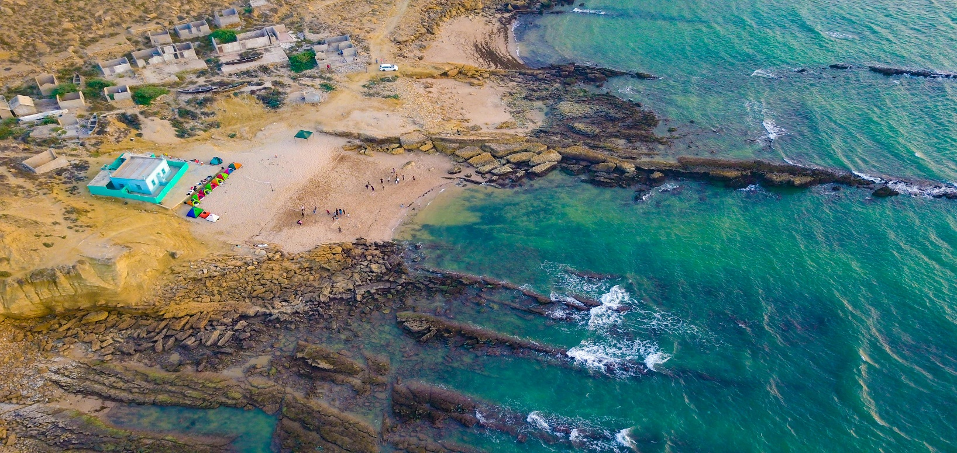

**FRENCH BEACH**

**Discover the Hidden Paradise of French Beach**

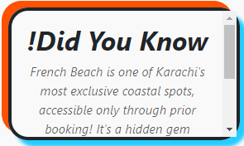Tucked away from the hustle and bustle of Karachi’s vibrant city life, French Beach is a hidden gem along Pakistan’s southern coastline. This serene and secluded spot is renowned for its picturesque views, unspoiled natural beauty, and exclusive atmosphere. Unlike the more public beaches, French Beach offers a peaceful retreat where visitors can escape the chaos of everyday life and immerse themselves in nature. The combination of rocky shores, soft sand, and calm turquoise waters makes French Beach a unique destination for those seeking a tranquil getaway.

**The Crystal-Clear Waters of French Beach**

One of French Beach’s standout features is its

stunningly clear waters, which captivate visitors

with their shimmering hues of blue and green. These pristine waters make the beach an ideal destination for a variety of water-based activities. Whether you’re diving into the cool waves for a swim, snorkeling to explore the vibrant underwater life, or simply relaxing by the shore, the experience is both refreshing and rejuvenating. The clear waters, coupled with the peaceful surroundings, create a sense of serenity that makes French Beach a perfect escape from the heat and stress of city life.

**A Retreat for Peace, Privacy, and Relaxation**

French Beach is often described as a haven of peace, offering a level of privacy that is hard to find on other Karachi beaches. Accessible primarily to members of the nearby huts or private groups, it is free from the typical crowds that populate most public beaches. The tranquil environment, combined with the soothing sounds of the waves, provides the perfect backdrop for relaxation. Families, couples, and small groups frequent this exclusive spot to enjoy quality time, away from the distractions of everyday life. French Beach’s serene ambiance makes it an ideal place for a picnic, a romantic outing, or simply unwinding in the lap of nature.

**A Unique Blend of Nature, Adventure, and Charm**

French Beach offers more than just a picturesque view; it’s a destination that seamlessly blends natural beauty with adventure. The rugged coastline, dotted with rocky formations, provides an exciting landscape for exploration and photography. For thrill-seekers, activities like paddleboarding, jet skiing, and even surfing during the monsoon season add an adrenaline-pumping edge to the experience. The beach’s untouched charm and diverse offerings make it a favorite for adventurers and nature lovers alike. Whether you’re gazing at the breathtaking sunset, enjoying a barbecue by the sea, or exploring the rocky shores, French Beach promises an unforgettable experience.

***RIDING***

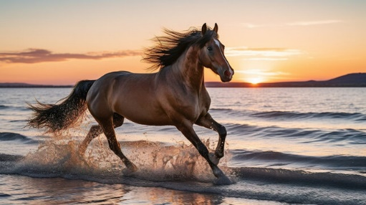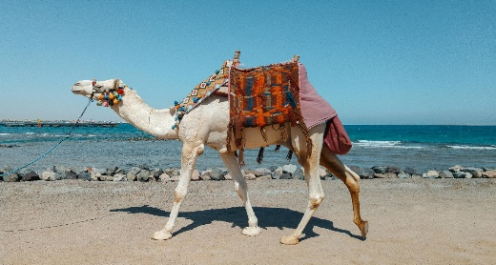

***! Horse riding at FRENCH Beach is another thrilling activity for visitors. Beautifully adorned horses are available for guided rides along the shoreline.***

***! Camel riding at FRENCH BEACH is a fun and iconic activity for visitors. Decorated camels offer safe rides guided by skilled handlers.***

***! Beach bike riding at FRENCH Beach offers a thrilling experience, with rental bikes designed for smooth rides on the sandy shoreline.***

**Unveiling the Tranquil Beauty of French Beach karachi:**

French Beach is a coastal sanctuary that offers a stark contrast to the vibrant and fast-paced life of Karachi. Nestled between Hawkesbay and Paradise Point, this pristine stretch of shoreline is famed for its rugged natural beauty, rocky landscapes, and crystal-clear waters. Unlike other crowded beaches in Karachi, French Beach is a private and secluded getaway that attracts those seeking solace in nature. Its picturesque surroundings, highlighted by the soothing sound of waves and the endless expanse of the Arabian Sea, make it an idyllic escape for anyone looking to unwind.  
  
The beach's exclusivity, preserved by the private huts dotting the area, adds an air of luxury to the experience. French Beach isn't just a destination—it's a retreat into a world of tranquility and serenity, away from the chaos of urban life.

**French Beach: A Perfect Blend of Adventure and Natural Splendor**

French Beach stands out as a perfect fusion of elegance and adventure, offering something for everyone. The azure waters are ideal for a range of activities such as swimming, snorkeling, and paddleboarding, while the surrounding rocky shores provide a picturesque landscape for exploration and photography. During the monsoon season, French Beach becomes a haven for surfers who flock to catch its thrilling waves. The exclusivity of the beach is further enhanced by the private huts that line the shore, giving visitors a chance to enjoy a luxurious, peaceful experience with their loved ones. Whether you're looking for an adrenaline-filled adventure, a peaceful day by the sea, or a memorable evening under a sky full of stars, French Beach delivers an unforgettable coastal experience.

**LOCATION**

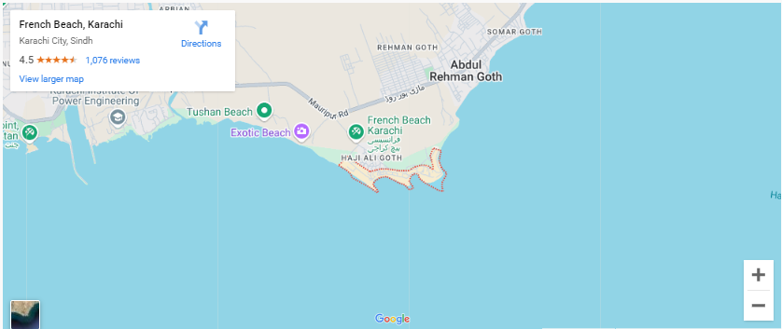

**French Beach is located in the Hawksbay area, about 40 km west of Karachi. It’s a private, serene beach known for its peaceful environment.**

**Why Visit French Beach?**

French Beach offers a unique blend of exclusivity, natural beauty, and adventure, making it one of Karachi's most sought-after coastal destinations. Unlike bustling public beaches, French Beach provides a serene and private retreat for families, friends, and couples seeking tranquility. The turquoise waters, rocky shorelines, and breathtaking sunsets create an enchanting ambiance, perfect for relaxation and rejuvenation. Adventurers can dive into activities like snorkeling, surfing during the monsoon season, and paddleboarding, while photographers can capture the rugged beauty of the landscape. Whether you’re planning a peaceful day by the sea or an adrenaline-packed excursion, French Beach promises a one-of-a-kind experience that will leave lasting memories.



**FEATURED PRODUCT**



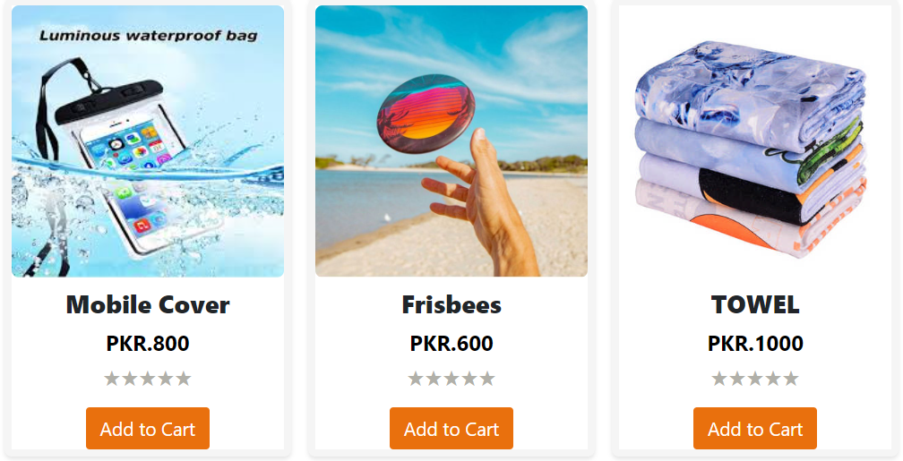

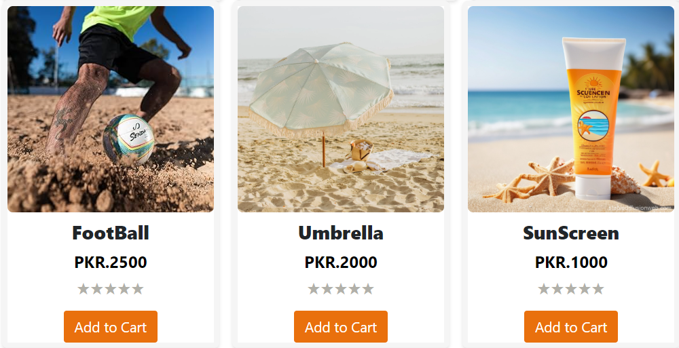

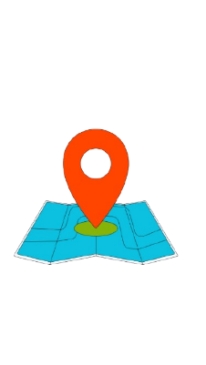**SHOP LOCATION**

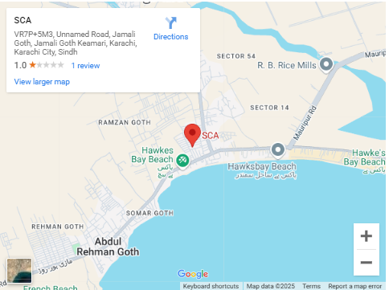

VR7P+5M3,UNNAMED ROAD, JAMALI GOTH, JAMALI GOTH

KEAMARI, KARACHI CITY SINDH.